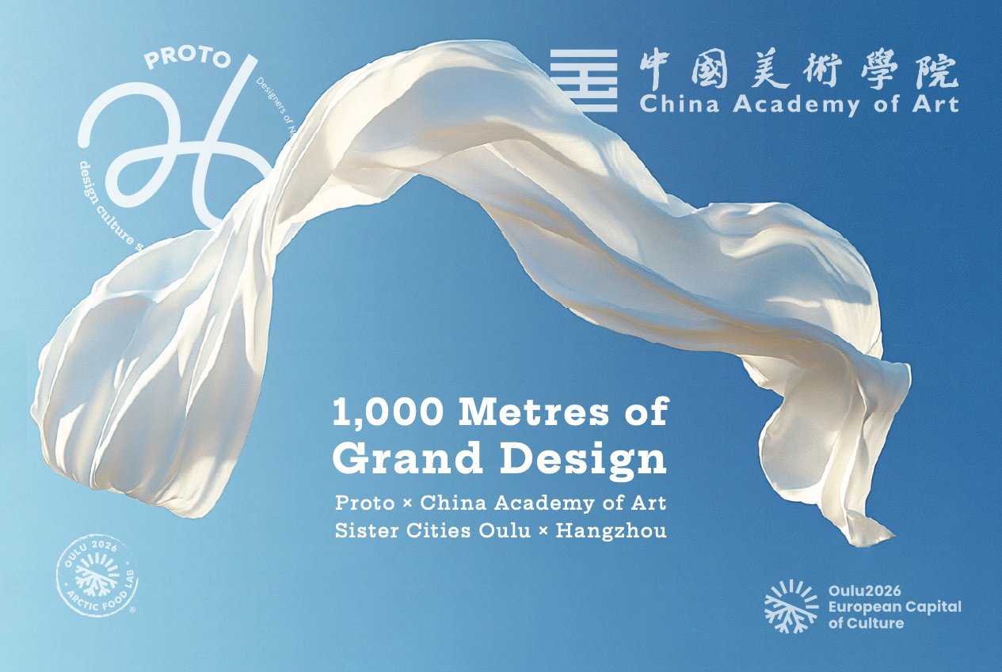

Media release 27 March 2025

**1,000 Metres of Grand Design — Unique collaboration between Proto Designers and China Academy of Art**

***Susanna Sivonen****, a power house of design and art at Proto Designers will work together with a multi-disciplinary group of design students at China Academy of Art in a workshop on 7—11 April to design a unique 1,000 metre tablecloth to honour and foster the friendship between Sister Cities Hangzhou and Oulu, and to celebrate @Oulu2026 European Capital of Culture.*

The collaboration initiated by Proto—Designers of Northern Finland with China Academy of Art is the first collaborative project between CAA and a Finnish design organisation. The project is made possible with the creative input from the brilliant staff and gifted students at CAA, one of the best art and design universities in China, merged with inspiration from the North.

The 1,000 Metres of Grand Design will continue till mid-December this year as a major scale student project at CAA. The tablecloth will be printed in Hangzhou in the beginning of 2026, and shipped to Oulu by 1st June 2026.

The design student team and academic representatives from CAA together with representatives of City of Hangzhou will be invited to celebrate conviviality and friendship between residents, visitors and cities and to join the Summer Night’s Dinner, the table set by Arctic Food Lab to highlight the unique flavours and food culture of Northern Finland as part of European Capital of Culture Year.

Everyone is invited. The 1,000 metre table will be set between the railway station and the market square in the city centre of Oulu. At best more than 3,000 people — residents from Oulu and all 40 cities, towns and municipalities taking part in the European Capital of Culture activities together with visitors and invited guests — will sit round the table in the open air to enjoy the unique light of a summer night in North of Finland.

The 1,000 metres of designed fabric is not just a tablecloth. It creates a rich inter-cultural platform for something most cultures recognise as an act of kindness, friendship and peace — sharing and enjoying food together. Proto Designers are proud to have the creative talents at China Academy of Art collaborating to make this happen.

Partner organisations and contacts for more information

Proto Designers represents design professionals from all design fields in Northern Finland since late 1980’s. Besides 1,000 Metres of Grand Design, Proto2026 Design Programme highlights everyday design at Proto Design Centre through 2026, <https://proto.fi/en/13808-2/proto2026/>.

Contact Päivi Tahkokallio, Proto2026 Design Programme Director, [paivi@tahkokallio.fi](mailto:paivi@tahkokallio.fi),

+358 324 3517, or

Susanna Sivonen, Designer and Artist, Proto Designers, [sivonensusanna@gmail.com](mailto:sivonensusanna@gmail.com)

China Academy of Art is one of the best design and art universities in China, with both a major creative and financial input in the project. Located in Hangzhou, the Sister City of Oulu has 10 000 students. School of Fashion Design SFD will manage the design project at CAA, selecting 20 students from study programmes across design disciplines to join.

Contact Zhou Yuanyang, Lecturer at SFD, CAA, [yuanyangzhou2018@gmail.com](mailto:yuanyangzhou2018@gmail.com)

Oulu is the European Capital of Culture in 2026. Oulu and northern Finland will be filled with culture, art, and events. Northern Finland will rise to the world map in an unprecedented way as Finnish and international cultural experts create something new in cities, countryside, and nature. It is a journey spanning several years, culminating in the year 2026. Oulu Cultural Foundation supports 1,000 Metres of Grand Design financially. <https://oulu2026.eu/en/>.

Contact Niina Keränen, Arctic Food Lab Project Manager, [niina.m.keranen@oulu2026.eu](mailto:niina.m.keranen@oulu2026.eu).

Oulu and Hangzhou have been Sister Cities since 2010 with the aim of fostering the encounter of different people and cultures through promoting multidisciplinary cultural, educational, entrepreneurship and business cooperation between the cities.

Contact Outi Rouru, Head of Public Relations and Protocol at City of Oulu, [outi.rouru@ouka.fi](mailto:outi.rouru@ouka.fi)

Social media

#ProtoDesigners

#Proto2026

@Proto—Designers of Northern Finland

@Proto—Pohjois-Suomen Muotoilijat

#ChinaAcademyofArt

#SchoolofFashionDesignCAA

#Oulu2026

#CulturalClimateChange

#Kulttuuriilmastonmuutos

@Oulu2026Official

#Oulu

@oulunkaupunki

@cityofoulu

#ArcticFoodLab

#Hangzhou